This will be the title of the paper which will include the primary focus of the case presented in the report followed by the words “case report”
First name & family name of first author e.g. “Josh A. Murray”¹, Second author², Third Author³
¹Affiliation of the first author in the form of: Department Name, Name of Institution, City, Country
²Department Name, Name of Institution, City, Country (second author’s affiliation)
³Department Name, Name of Institution, City, Country (third author’s affiliation)
Corresponding Author’s information: Full name, address, email address, telephone and/or fax number of the author responsible for the submission. DO NOT include titles such as Dr., General Manager... To avoid confusion, the family name must always be written as the last part of each author name (e.g. Josh A. Murray).
Name of Department and Institution where the work was done.
Financial support: in the form of grants, “quoting the number granted”, instruments or other. If no financial support received please write as follow: “none”.
Conflict of interest: if any please specify here, if no conflict of interest is identified please write “none”.
Patient Consent: Patient’s written consent for the publication of this case and images was taken.
Abstract
Background: This is where you will briefly summarize the relevant information of the presented case in a structured format, WITHOUT CITATIONS. Kindly note that the use of the “Times New Roman” font with a 12-point typeface, 1.5 line spacing and a 2.5 cm margin (1 inch) from all borders of the page must be maintained, in accordance with the Uniform Requirements for Manuscripts Submitted to Biomedical Journals. In this section you will summarize the background of the main topic.
Case Report: In this section, you will highlight the patient information including the primary symptoms, diagnostic methods and challenges, therapeutic intervention and outcomes.
Conclusion: In this section you will briefly summarize why the case is unique and/or what are the lessons to be learned from this case report.

Keywords: Specify 3 to 6 keywords or short phrases that identify diagnoses or interventions, separated by commas, including “case report”. One way to choose the keywords is the see which words are most repeated in the article.

Background
Citations in square brackets “[1]” may begin in this section of the manuscript. Kindly note that they should be numbered in the order in which they were cited; TIP: to simplify your task, DO NOT do this manually, seek an automated web-based bibliography and database manager such as RefWorks, EndNote, Mendeley, etc… This will make it easier for you to keep the numbers in order and automatically formats the paper and bibliography in seconds.
As for this section, it will include developed background information related to the case with literature review of the disease history, its presentation, epidemiology, etiologies, risk factors, diagnostic methods and challenges, and therapeutic interventions including pharmacologic, surgical and preventive. Introductions that are too short and omit relevant literature reviews will not be accepted. A sentence restating the importance of reporting this case and introducing the following section is recommended.
Case Presentation
Your case report starts here. Write the case in complete sentences in narrative form. Keep the sentences short and clear. Make sure that the pronouns used to replace a subject/object are clear from the context and do not cause confusion. You may break your report into paragraphs, but be sure to include:
- Patient demographics: age, gender, ethnicity (if relevant to the medical condition), age at diagnosis of related medical problem if different from the patient’s age. Make sure patient’s confidentiality is respected.
- Patient’s clinical presentation
- Patient’s relevant past medical and surgical history as well as relevant family history, home medications, specific disease risk factors (tobacco smoking, alcohol, substance abuse, occupation...)
- Relevant physical exam findings (findings that both favor or disfavor a differential diagnosis)
- Diagnostic approaches opted for and their detailed findings (for instance, if laboratory results are reported, make sure to include units and reference ranges; if radiologic approaches were used make sure to include appropriate images, )
- Management plan:
- pharmacologic (generic name, dose, route of administration and duration of treatment)
- surgical techniques employed (the more details provided the more likely the paper will be accepted, e.g: if a surgery was opted for, include an edited small video showing the major steps of the surgery; if the case is one where before and after images may be provided such as in reconstructive surgeries, these are also to be included).
- Patient outcome and follow-up: clinical solution of the presented case, how did the patient respond to treatment, were there any treatment complications, what is the follow-up plan or how did the patient do if that information is available.
Figures, imaging, tables, videos, will be presented in the end of the file with appropriate descriptive legends. The text should include references to the appropriate headings in the proper places, i.e. when describing the imaging modalities used and their findings refer to the related figure at the end of the document as follow “(Fig. 1)”. We will place the file as close as possible to that sentence in the final layout design.
Discussion
Discuss your case in reference to clinical practice and literature. Do not repeat in detail data or other material from the Introduction or the Case Report section. Discuss the findings and limitations of the diagnostic and therapeutic approaches and possible alternatives if any. Discuss the patient outcome as related to the management that was opted for. In summary, discussion should highlight the similarities or differences between your case and the medical literature while emphasizing the new and/or important aspects of the case presented (rare disease, challenging diagnosis, misleading presentation, delayed management and prognosis implications, adequacy of management plan, patient related factors, other diagnostic tests that could have been used, etc…).

Conclusion
State new hypotheses and include recommendations when appropriate. Do not provide statements and conclusions that are not completely supported by the data. Restate the importance of this case report and the take home messages.

Acknowledgements:
Contributors who do not meet the criteria for authorship should be listed here to acknowledge their efforts and support (technical assistants, writing assistants or head of department who provided only general support). Financial support should be disclosed and acknowledged.

References:
References must be in the American Medical Association (AMA) reference style followed by the PMID if applicable and the doi link of the article as follows:
1. Riley DS, Barber MS, Kienle GS, et al. CARE guidelines for case reports: explanation and elaboration document. J Clin Epidemiol. 2017;89:218-235. PMID: 28529185. https://doi.org/10.1016/j.jclinepi.2017.04.026
Your references must be up to date. Please avoid using old publications, you must provide important additional reading opportunities. Make sure you accurately describe previous work and adequately reference it within the text. Do not provide any literature data without referencing. In-text citations are checked and inappropriate style or double referencing will be returned for modification, only prolonging the process.
Thank you for taking the time to read this template. This document is provided to you in the form of .docx, so that you can use it as a template before submitting your manuscript. We hope we have answered your questions.

“The CARE Guidelines Checklist for Case Reports” is in the last page for your reference (Fig.1).

For more information, feel free to contact us.
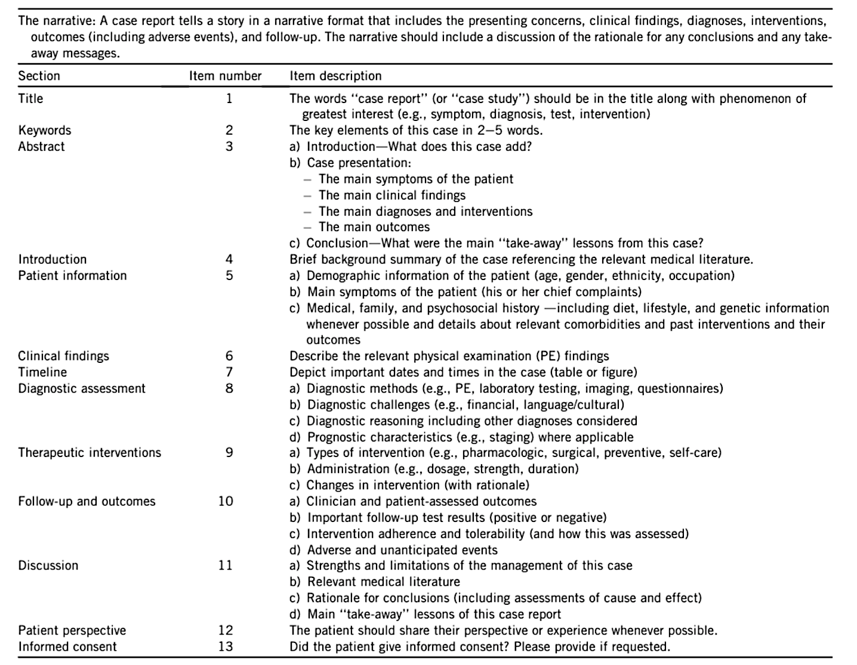
Figure 1: CARE Guidelines Checklist for Case Reports. Retrieved from Riley DS, Barber MS, Kienle GS, et al. CARE guidelines for case reports: explanation and elaboration document. J Clin Epidemiol. 2017;89:218-235. http://dx.doi.org/10.1016/j.jclinepi.2017.04.026

